Dhaka Stock Exchange Limited
“DSE-Tower” Plot # 46, Road # 21, Nikunja -2, Dhaka -1229.

DECLARATION OF ANY ACTUAL OR POTENTIAL CONFIDENTIALITY, CONFLICT OF INTEREST, INVESTMENT OR TRADING IN LISTED SECURITIES AS PER THE CONDITIONS OF SERVICE RULES 2017 (CLAUSE 14).
In pursuance to the provision of Rule 14.3 of DSE Employee Service Rules-2017 “During the employment with DSE, no employee or dependents of the employee shall engage themselves in Investment or trading of listed Securities or Securities to be listed with DSE directly or indirectly”.
Employee Details:

Name: MD. SAIFUL ISLAM Designation: Senior Executive
Department: Back Office Division: ICT
EIN: 496 NID No: 5532793436 BOID (if any):

Employee Declaration

- I / any of my family member(s)/Authorized person(s) of any Beneficiary Owner (B.O) Account holder do not hold shares in any listed securities.

- I do not Authorize any person involved in share trading of listed securities.

- I / my family member(s) hold shares in a company/ I have a direct/indirect personal interest in a trade/business undertaking (if any please complete the relevant section below):

SL No | Dependent Type | Name of the Dependent | National ID | BO ID | Investment Details
1 | Spouse
2 | Father
3 | Mother
4 | Child 1
5 | Child 2
6 | Authorized

Others Information (if any):

I declare that the information I have given on this form is correct and complete. I understand that if the above information provided by me is found incorrect or misleading disciplinary action may be taken as per Service Rules of DSE.
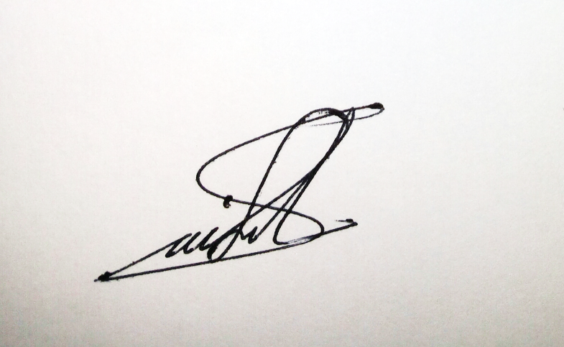
07/09/2021
----------------------------- Signature & Date:

Note: This form must be updated in every 180 days and submitted to the HR Department. Please attach the supporting document(s) that is relevant to this application.

